Contents
1 Introduction 1
1.1 System Introduction 1
1.2 Background of the System 1
1.3 Objectives of the System 1
1.4 Significance of the System 1
2 Overall Description 2
2.1 Product Perspective 2
2.2 Product Scope 2
2.3 Product Functionality 2
2.4 Users and Characteristics 2
2.5 Operating Environment 2
3 Specific Requirements 3
3.1 Functional Requirements 3
3.2 Behaviour Requirements 3
3.3 External Interface Requirements 3
3.3.1 User Interfaces 3
3.3.2 Hardware Interfaces 3
3.3.3 Software Interfaces 3
3.3.4 Communications Interfaces 4
4 Other Non-functional Requirements 5
4.1 Performance Requirements 5
4.2 Safety and Security Requirements 5
4.3 Software Quality Attributes 5
5 Design Description 6
5.1 Composite Viewpoint 6
5.2 Logical Viewpoint 6
5.3 Information Viewpoint 6
5.4 Interaction Viewpoint 6
5.5 State Dynamics Viewpoint 6
5.6 Algorithm Viewpoint 6

1 Introduction

System Introduction
Study Sphere is an Android-based application designed to enhance the learning experience for students by integrating study management with social collaboration features. It serves as a platform where students can manage study materials, collaborate with peers, generate quizzes and summaries, track their progress, and earn rewards, all under administrative oversight. Key features include group collaboration, study material sharing, quiz generation, progress tracking, and a reward system to motivate students. Study Sphere aims to foster a collaborative and engaging learning environment, combining academic tools with social interaction to support students in achieving their educational goals.

Background of the System
In the digital age, education has increasingly shifted towards online and collaborative platforms, yet many students still struggle with organizing study materials, staying motivated, and collaborating effectively with peers. Traditional study methods often lack the interactivity and community support that modern learners need. Recognizing this gap, Study Sphere was developed as an innovative mobile application to revolutionize the way students study by integrating academic tools with social features. The idea behind the Study Sphere is to transform the solitary act of studying into a collaborative and rewarding experience, leveraging technology to connect students globally and provide them with tools to enhance their learning efficiency.

Objectives of the System
• Provide a digital platform that enhances the study experience, making it more interactive, organized, and rewarding for students.
• Create a space where students can collaborate with peers, share study materials, and engage in group discussions, fostering a sense of community.
• Offer tools for generating summaries, quizzes, and Q&A sessions to support active learning and self-assessment.
• Enable students to track their progress and earn rewards, encouraging consistent study habits and motivation.
• Provide administrative oversight to ensure a safe and productive environment for all users.

Significance of the System

Study Sphere addresses the modern need for a comprehensive study platform that combines academic tools with social collaboration. By enabling students to manage study materials, collaborate with friends, and track their progress, Study Sphere enhances the learning experience, making it more engaging and efficient. The system fosters a global community of learners, allowing students to connect over shared academic interests, share resources, and support each other. Additionally, the reward system motivates students to stay committed to their studies, while administrative oversight ensures a safe and constructive environment. Study Sphere supports education by providing tools for organization, self-assessment, and collaboration, ultimately contributing to improved academic outcomes and a deeper appreciation for learning.

Overall Description

Product Perspective
Study Sphere operates at the intersection of educational tools and social collaboration platforms, distinguishing itself by focusing on student-centric features. Unlike generic study apps or social media platforms, Study Sphere integrates study management with peer collaboration, offering functionalities like group creation, study material sharing, quiz generation, and progress tracking. It leverages technologies such as mobile connectivity, cloud storage for study materials, and real-time chat functionalities, innovating in how they are applied to education.

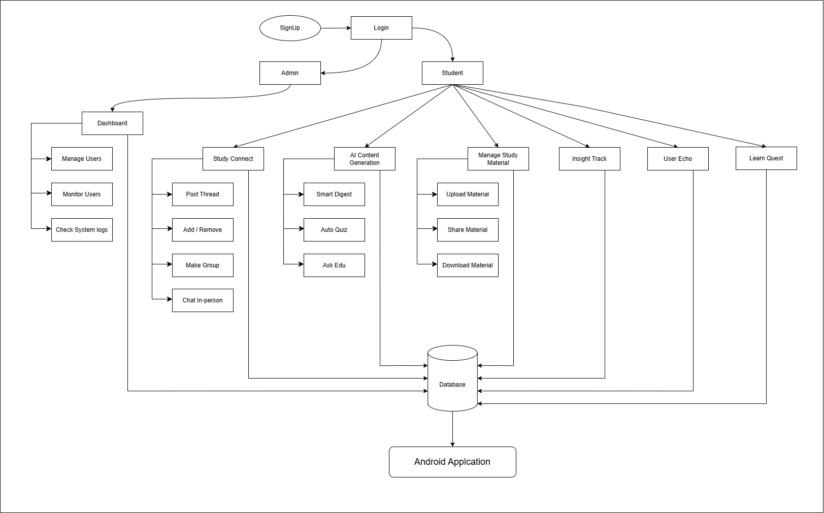

Product Scope
Study Sphere is designed to be a comprehensive platform for students, aiming to redefine how they study and collaborate. Its scope includes features for managing study materials (uploading, categorizing, sharing, downloading), collaborating with peers (group creation, chatting, posting threads), generating learning resources (summaries, quizzes, Q&A), tracking progress, and earning rewards. The system also includes administrative oversight to monitor user activities and ensure a safe environment. Study Sphere seeks to bridge the gap between individual study and collaborative learning, creating a vibrant community where students can support each other academically.

Product Functionality
2.3.1 Study Management
- Material Management: Students can upload, categorize, share, and download study materials, ensuring easy access and organization.
- Summary and Quiz Generation: Students can generate summaries and quizzes from study materials to aid in learning and self-assessment.
- Progress Tracking: Students can monitor their study progress, including quiz scores and completed materials, to stay on track with their goals.
2.3.2 Collaboration Features
- Group Collaboration: Students can create groups, post discussion threads, and chat with friends, fostering collaborative learning.
- Q&A Sessions: Students can ask questions and receive answers from peers or the system, promoting knowledge sharing.
2.3.3 Engagement and Oversight
- Rewards System: Students earn rewards (e.g., points, badges) for completing activities like quizzes, motivating consistent engagement.
- Administrative Monitoring: Admins can monitor user activities to ensure proper usage and maintain a safe environment.

Users and Characteristics
- Student:
  - Description: Primary users who use the app to study, collaborate, and track progress. They vary in academic levels, study habits, and technological expertise.
  - Activities: Registering, logging in, managing study materials, collaborating with friends, generating quizzes, tracking progress, giving feedback, and earning rewards.

- Admin:
  - Description: Oversees the app’s functionality, manages users, and ensures a safe environment.
  - Activities: Monitoring user activities, managing user accounts, and resolving issues.

Operating Environment
Study Sphere is an Android application developed using Flutter, with Firebase as the back-end database for real-time data storage and user authentication.

- Hardware Platform: Designed to run on smartphones and tablets.
  - Minimum Requirements:
    - Processor: Quad-core or equivalent
    - RAM: At least 4 GB
    - Storage: Minimum of 100 MB of free storage space, with additional space for user data (e.g., study materials, quiz results).
- Operating System:
  - Android: Supports Android 5.0 (Lollipop) and higher.
  - iOS: Not supported.
- Other Requirements:
  - Internet Connection: A stable internet connection is required for data synchronization and real-time collaboration.
  - Permissions: The app requires permissions for storage access and network connectivity

Specific Requirements

Functional Requirements

User Account Management
Requirement Number | Requirement | Description
SFR-001 | User Registration | Users can create accounts using email via Firebase Authentication.
SFR-002 | User Login | Users log in with credentials or single sign-on methods.
SFR-003 | Profile Management | Users update profiles, including bio, profile picture, and privacy settings for AI processing.

Note Sharing
Requirement Number | Requirement | Description
SFR-004 | Upload Notes | Users upload study materials (PDFs, images).
SFR-005 | Share Notes | Users share notes publicly or within private study groups.
SFR-006 | Search Notes | Users search notes using tags, categories, or keywords.

Discussion and Collaboration
Requirement Number | Requirement | Description
SFR-007 | Discussion Threads | Users post questions and replies in forum-style discussions.
SFR-008 | Group Chats | Users create/join public or private group chats with file-sharing capabilities.
SFR-009 | Notifications | Users receive real-time notifications for new messages or thread replies.

AI-Powered Tools
Requirement Number | Requirement | Description
SFR-010 | Text Summarization | AI generates brief, medium, or detailed summaries from uploaded content.
SFR-011 | Quiz Generation | AI creates quizzes (MCQs, True/False, fill-in-the-blank) based on study materials.
SFR-012 | Context-Aware Q&A | Users ask questions on uploaded content, receiving accurate responses via RAG framework.

Gamified Learning
Requirement Number | Requirement | Description
SFR-013 | Reward System | Users earn points/badges for activities like note sharing, quiz completion, and discussions.
SFR-014 | Leaderboards | Display user rankings based on earned points to encourage participation.

Progress Tracking
Requirement Number | Requirement | Description
SFR-015 | Activity Logging | Track time spent on summaries, quizzes, and discussions.
SFR-016 | Progress Reports | Generate visual charts/reports highlighting strengths and areas for improvement.

Administrative Functions
Requirement Number | Requirement | Description
SFR-017 | User Management | Admins view, suspend, or delete user accounts.
SFR-018 | Content Moderation | Moderators review and approve user-generated content.
SFR-019 | Feedback Review | Admins access and act on user feedback via surveys and suggestion boxes.

Behaviour Requirements

Use Case Diagram for Study Sphere
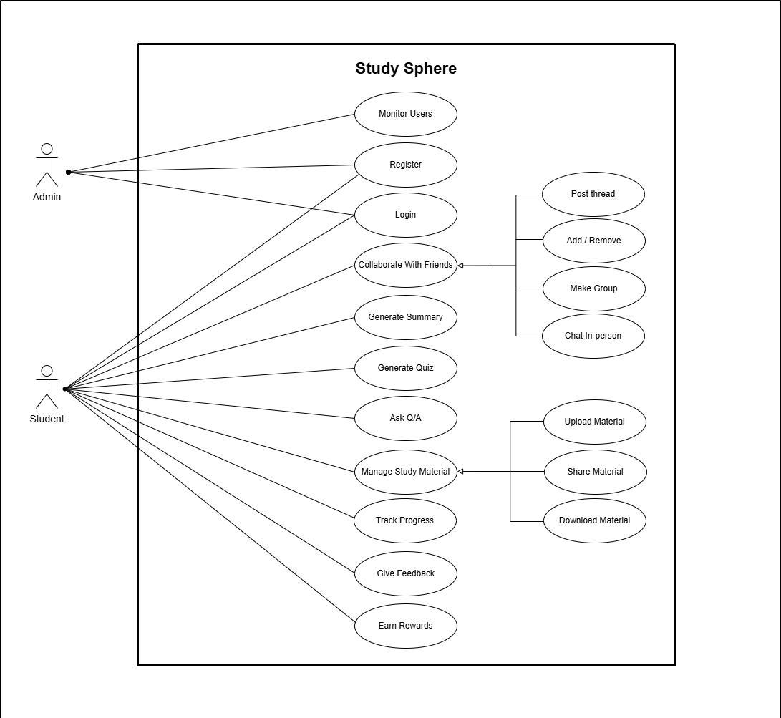

Use Case #1: Monitor Users
Field | Details
Actors | Admin
Description | The admin monitors the activities of students to ensure proper usage.
Pre-Condition | Admin must be logged into the system with appropriate permissions.
Steps | 1. Admin logs into the system.  2. Admin selects the "Monitor Users" option.  3. System displays user activity data.  4. Admin reviews the data.
Post-Condition | Admin receives a report or dashboard of user activities.

Use Case #2: Register
Field | Details
Actors | Student
Description | A student creates an account to access the Study Sphere system.
Pre-Condition | The student must not already have an account.
Steps | 1. Student accesses the registration page.  2. Student provides required details (e.g., name, email, password).  3. System validates the input.  4. System creates the account.
Post-Condition | The student is registered and can log in.

Use Case #3: Login
Field | Details
Actors | Student, Admin
Description | A User logs into the system to access its features.
Pre-Condition | The User must have a registered account.
Steps | 1. User enters their credentials (e.g., email, password).  2. System verifies the credentials.  3. System grants access and redirects to the dashboard.
Post-Condition | The User is authenticated and gains access.

Use Case #4: Collaborate with Friends
Field | Details
Actors | Student
Description | A student collaborates with friends by creating groups, posting threads, chatting.
Pre-Condition | The student must be logged in.
Steps | 1. Student selects the "Collaborate with Friends" option.  2. Student chooses to create a group, post a thread, chat or add/remove a friend.  3. System facilitates the chosen action.
Post-Condition | The student successfully collaborates with friends.
Relationships | Extends: Post Thread, Add/Remove, Make Group, Chat.

Use Case #5: Generate Summary
Field | Details
Actors | Student
Description | A student generates a summary of study materials.
Pre-Condition | The student must be logged in and have content available.
Steps | 1. Student selects the "Generate Summary" option.  2. Student uploads the content to summarize.  3. System generates a summary.
Post-Condition | A summary is generated and available to the student.

Use Case #6: Generate Quiz
Field | Details
Actors | Student
Description | A student generates a quiz based on study materials.
Pre-Condition | The student must be logged in and have study materials available.
Steps | 1. Student selects the "Generate Quiz" option.  2. Student chooses the study material.  3. System generates a quiz with questions.
Post-Condition | A quiz is generated and available for the student.

Use Case #7: Ask Q/A
Field | Details
Actors | Student
Description | A student asks questions and receives answers from the system.
Pre-Condition | The student must be logged in.
Steps | 1. Student selects the "Ask Q/A" option.  2. Student submits a question.  3. System provide an answer.
Post-Condition | The student receives an answer to their question.

Use Case #8: Manage Study Material
Field | Details
Actors | Student
Description | A student manages study materials by uploading, categorizing, sharing, etc.
Pre-Condition | The student must be logged in.
Steps | 1. Student selects the "Manage Study Material" option.  2. Student chooses to upload, categorize, share, or download.  3. System performs the chosen action.
Post-Condition | Study materials are managed as per the student’s actions.
Relationships | Extends: Upload, Categorize, Share, Download.

Use Case #9: Track Progress
Field | Details
Actors | Student
Description | A student tracks their learning progress within the system.
Pre-Condition | The student must be logged in and have completed activities.
Steps | 1. Student selects the "Track Progress" option.  2. System displays the student’s progress (e.g., quiz scores, completed materials).
Post-Condition | The student views their progress report.

Use Case #10: Give Feedback
Field | Details
Actors | Student
Description | A student provides feedback on the system or study materials.
Pre-Condition | The student must be logged in.
Steps | 1. Student selects the "Give Feedback" option.  2. Student enters their feedback.  3. System submits the feedback.
Post-Condition | Feedback is submitted and stored in the system.

Use Case #11: Earn Rewards
Field | Details
Actors | Student
Description | A student earns rewards for completing activities (e.g., quizzes).
Pre-Condition | The student must be logged in and have completed a reward-eligible activity.
Steps | 1. Student completes an activity (e.g., a quiz).  2. System evaluates the activity for reward eligibility.  3. System awards the student a reward.
Post-Condition | The student receives a reward (e.g., points, badges).

External Interface Requirements

User Interfaces
Study Sphere offers a user-friendly interface designed for easy navigation and intuitive interaction.
- Home Screen:
  - Features: Provides quick access to study materials, collaboration groups, quizzes, and progress tracking.
  - Standard Buttons: Navigation bar with "Home," "Groups," "Materials," "Progress," and "Profile" tabs.
- Study Material Screen:
  - Features: Displays a list of study materials with options to upload, categorize, share, or download.
  - Standard Buttons: "Upload," "Categorize," "Share," and "Download" buttons.
- Collaboration Screen:
  - Features: Shows groups, threads, and chat options for collaboration.
  - Standard Buttons: "Create Group," "Post Thread," "Chat," and "Add/Remove Friends" buttons.
- Error Message Display Standards:
  - Error messages are clear, consistent, and appear as pop-up notifications with steps to resolve issues (e.g., network errors, validation errors).

Hardware Interfaces
- No extra hardware interfaces are needed.
- The system uses standard hardware resources, including network connectivity and storage

Software Interfaces
StudySphere integrates with various software components to deliver its functionality. This section details the connections between StudySphere and other software elements, including operating systems, databases, libraries, tools, and external services.
Operating System:
  - Supported Platforms: Android 5.0 (Marshmallow) and higher.
  - Purpose: Provides the runtime environment for the Flutter-based StudySphere app.
  - Interactions:
    - Permissions Management: Requests access to storage (for note uploads/downloads) and network connectivity (for Firebase communication).
    - Notifications: Uses Android’s notification system to deliver push notifications via Firebase Cloud Messaging.
    - Background Processing: Manages background tasks like data synchronization when the app is not in the foreground.
- Database and Backend Services:
  - Firebase Firestore:
    - Version: Latest stable version of Firebase Firestore SDK.
    - Purpose: Serves as the primary database for real-time storage of user data, study materials, discussion threads, chat messages, and progress logs.
    - Interactions:
      - Stores user profiles, uploaded notes (metadata and file references), discussion posts, and quiz results.
      - Supports real-time synchronization for collaborative features like group chats and shared notes.
      - Provides querying capabilities for note searches and progress analytics.
  - Firebase Authentication:
    - Version: Latest stable version of Firebase Authentication SDK.
    - Purpose: Manages secure user authentication and authorization.
    - Interactions:
      - Handles email-based registration/login, social media single sign-on (e.g., Google).
      - Ensures secure user sessions and role-based access (e.g., student vs. admin).
  - Firebase Cloud Storage:
    - Version: Latest stable version of Firebase Storage SDK.
    - Purpose: Stores large files such as PDFs and images uploaded as study materials.
    - Interactions:
      - Uploads files to secure cloud storage with unique references linked to Firestore metadata.
      - Supports file downloads and sharing within the app.
- Libraries and Plugins:
  - Flutter Plugins:
    - firebase_core: Initializes Firebase services within the Flutter app.
      - Purpose: Enables integration with Firebase Firestore, Authentication, Storage, and Cloud Messaging.
    - image_picker: Allows users to select images from the device gallery or camera for note uploads.
      - Purpose: Facilitates image-based content uploads.
    - shared_preferences: Stores local settings and cached data (e.g., user preferences, offline note metadata).
      - Purpose: Enhances performance by reducing server queries for frequently accessed data.
    - flutter_secure_storage: Stores sensitive data like authentication tokens securely.
      - Purpose: Protects user session data on the device.
  - Python Libraries (Backend AI Processing):
    - transformers (Hugging Face): Used for NLP tasks in SmartDigest (summarization) and AutoQuiz (quiz generation).
      - Purpose: Processes text to generate summaries and quiz questions.
    - sentence-transformers: Supports AskEdu’s RAG framework for context-aware Q&A.
      - Purpose: Encodes text for semantic search and answer generation.
    - fastapi: Runs the Python backend server for AI processing.
      - Purpose: Exposes APIs for the Flutter app to send content and receive AI-generated results.
- External Services:
  - Analytics Tools (e.g., Firebase Analytics):
    - Purpose: Tracks user interactions (e.g., note uploads, quiz completions) for progress insights and platform improvements.
    - Interactions: Collects anonymized data on feature usage and performance metrics.
.

Communications Interfaces
StudySphere relies on robust communication interfaces to support real-time collaboration, data synchronization, and user notifications. This section outlines the communication functions, standards, security measures, and synchronization mechanisms specific to StudySphere’s implementation.
- Communication Standards:
  - HTTPS:
    - Purpose: Ensures secure communication between the StudySphere app and Firebase services (Firestore, Storage, Authentication).
    - Implementation: All API calls and data transfers use HTTPS to encrypt data in transit.
  - WebSocket-like Real-Time Sync (Firestore):
    - Purpose: Provides real-time updates for chats, discussion threads, and shared notes.
    - Implementation: Firestore’s real-time listeners monitor collection changes and push updates to the app.
  - Firebase Cloud Messaging (FCM):
    - Purpose: Delivers push notifications to Android devices.
    - Implementation: FCM sends lightweight messages to trigger app updates or user alerts.
  - REST API (FastAPI):
    - Purpose: Facilitates communication between the Flutter app and the Python backend for AI processing.
    - Implementation: The app sends POST requests with JSON payloads; the backend responds with processed data.
- Security and Encryption:
  - Data Encryption:
    - All data transmitted between the app and Firebase (Firestore, Storage, FCM) is encrypted using HTTPS/TLS.
    - Chat messages and uploaded files are stored encrypted in Firestore and Storage.
    - AI processing requests to the Python backend use HTTPS to secure content transmission.
  - Authentication:
    - Firebase Authentication secures user sessions with JSON Web Tokens (JWTs).
    - Role-based access ensures only authorized users (e.g., admins) can access sensitive functions.
- Data Transfer and Synchronization:
  - Real-Time Synchronization: The app relies on Firebase for real-time data synchronization, allowing users to receive instant updates.
  - Data Transfer Rates: The app is designed to work efficiently with typical mobile data transfer rates, ensuring smooth communication and minimal latency.

Other Non-functional Requirements

Performance Requirements
- Response Time: Most interactions (e.g., navigating screens, loading materials) should complete within 2 seconds under normal conditions.
- Startup Time: The app should start within 5 seconds on supported devices.
- Chat and Messaging: Messages should be delivered in real-time.
- Scalability: The system should handle increased loads (e.g., multiple users in a group chat) without performance degradation.
- Resource Utilization:
  - Memory Usage: Should remain within reasonable limits to prevent slowdowns.
  - Battery Consumption: Optimized to minimize battery drain during use

Safety and Security Requirements
- Safety Requirements:
  - Data Protection: User data (e.g., study materials, chat messages) must be protected against unauthorized access or loss.
  - Error Handling: The app should recover from errors without causing data loss or harm to users.
- Security Requirements:
  - User Authentication: Secure authentication mechanisms (e.g., email verification, password protection) to prevent unauthorized access.
  - Data Encryption: All data transmitted between the app and Firebase should be encrypted.
  - Access Control: Users should only access authorized functions and data.
  - Content Moderation: Admins can review and moderate user-generated content to ensure compliance with guidelines.

Software Quality Attributes
4.3.1 Reliability: Achieve 99.9% uptime with robust error handling.
- Strategy: Use Firebase’s reliable infrastructure and monitor with Crashlytics.

4.3.2 Usability: Intuitive UI with a 5-minute learning curve, validated by user feedback.
- Strategy: Consistent navigation and contextual help; refine via UserEcho.

4.3.2 Adaptability: Support integration of new AI models or features maintaining compatibility with existing data formats.

- Strategy:
  - Use a modular Flutter architecture with separate packages for AI modules (SmartDigest, AutoQuiz, AskEdu).

  - Implement a Python backend with versioned FastAPI endpoints for AI processing, allowing model updates without app changes.

4.3.4 Portability: Support Android 5.0+ on 95% of devices.
- Strategy: Test with Firebase Test Lab for cross-device compatibility.

Design Description

Composite Viewpoint
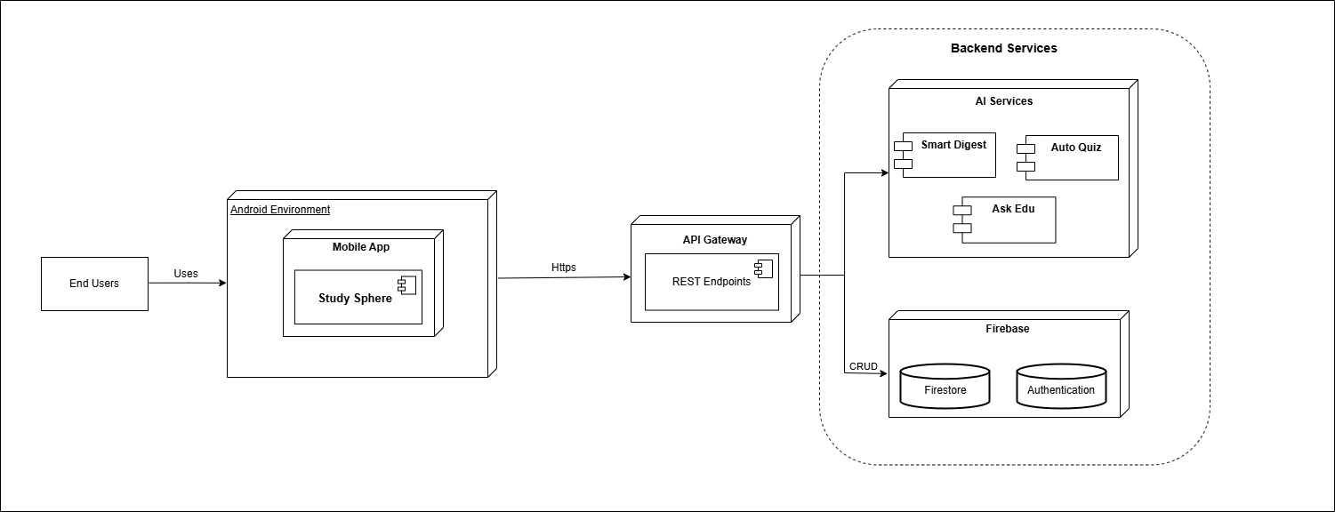
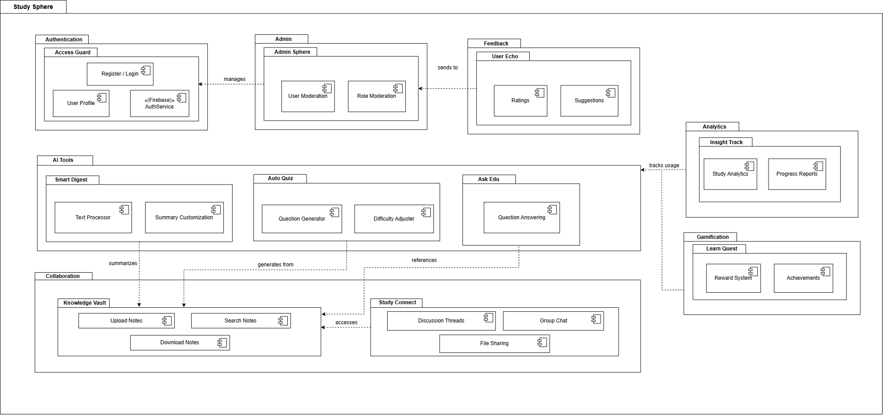

Logical Viewpoint

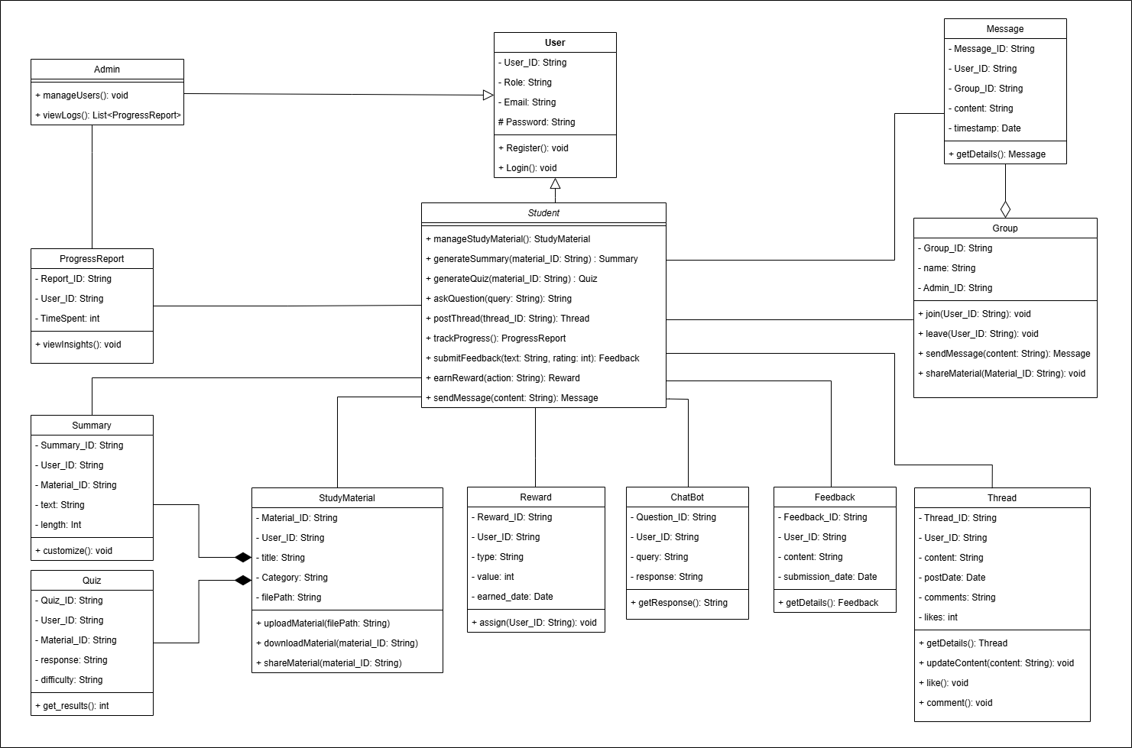

Information Viewpoint

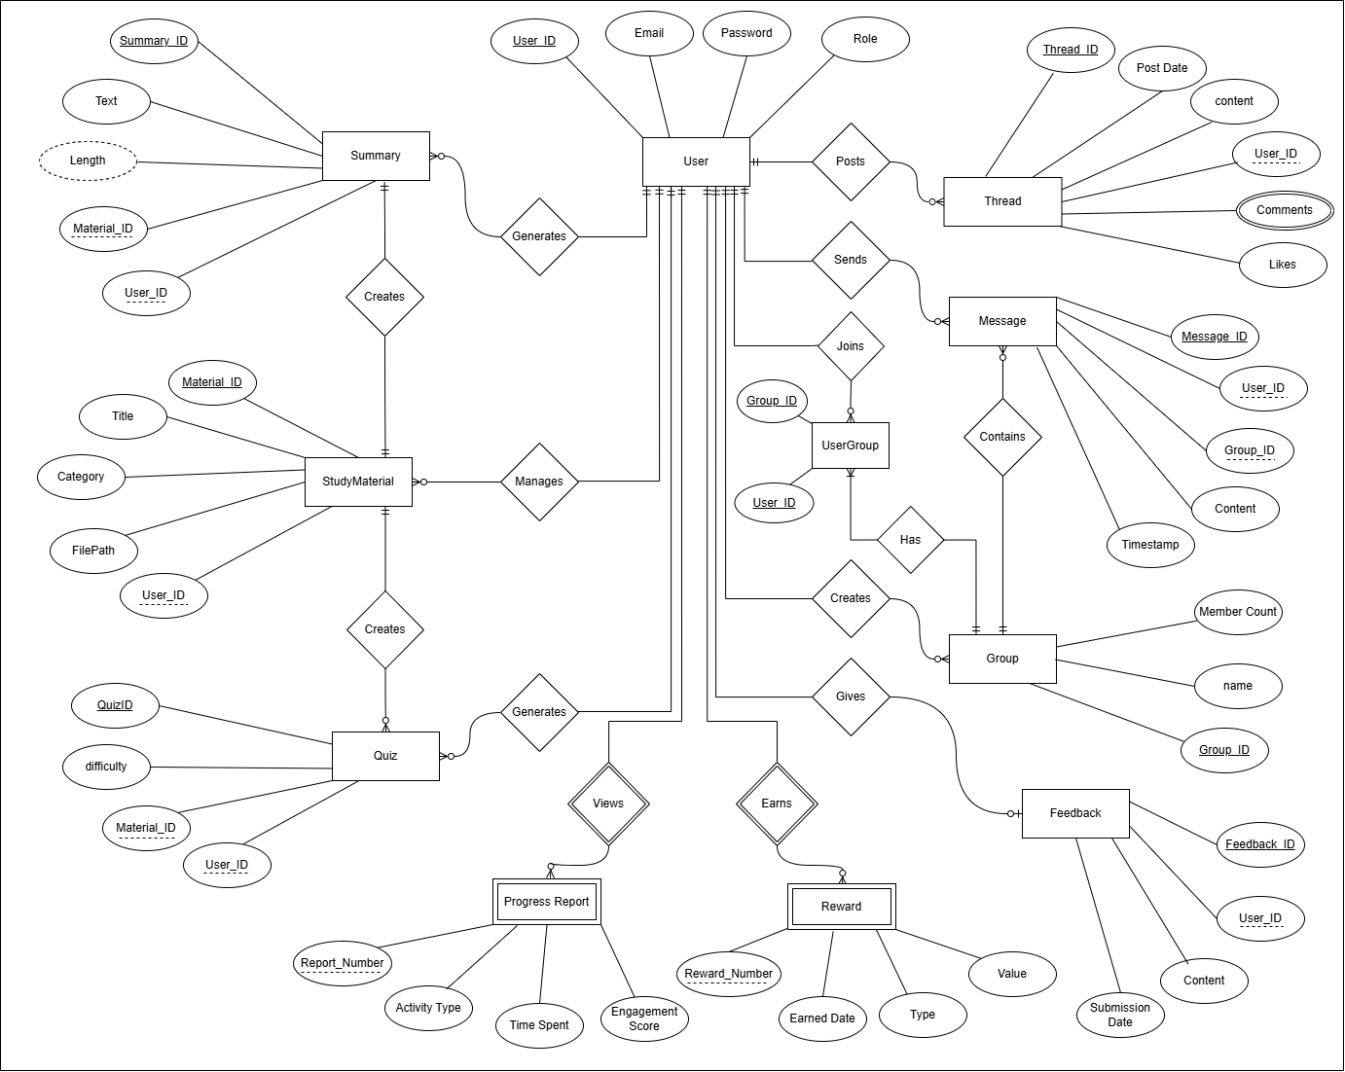

Interaction Viewpoint
<The Interaction Viewpoint defines strategies for interaction among objects. This could include designing with concurrent tasks and/or asynchronous messaging, messaging among objects, etc. The UML diagram used to serve the purpose is Sequence Diagram.
TO DO: Provide sequence diagrams for every use-case>

State Dynamics Viewpoint
<The State Dynamic Viewpoint expresses the Dynamic state transformations of the system under study. The UML diagrams used to serve the purpose are UML State Machine Diagram, State Transition Table (Matrix).
TO DO: UML State Machine Diagram/ State Transition Table (Matrix) for the software>

Algorithm Viewpoint
<The detailed design description of operations (methods, functions), this applies to components, classes, and individual methods as design entities. The UML diagrams used to serve the purpose are Decision Table, Pseudo Code.
TO DO: Provide Decision Table or Pseudo Code for the complete software>

